Process to add new Feature

Definition: A feature is composed of 3 parts: javascript, css and html.
Steps
1 - Define unique feature var name. Replace –tmp– on each template. Follow instructions.
2 - Public Folders
- Add script function into /js/ folder and apply header @ index.php. check /js/scripts.js
- Add css into /css/ folder and header @ index.php. check /css/style.css
- Construct class & html @ /class/class_feature_.php. (Follow class_feature_template.php)
- Call class from /includes/header.php
- add images into /images/
3 - Admin Folders
- Add edit script area into /admin/bin/edit_feature_.php (Follow edit_feature_template.php)
- Add update script into /admin/bin/update_feature_.php (Follow update_feature_template.php)
- Add feature name into db table -> RED_Features
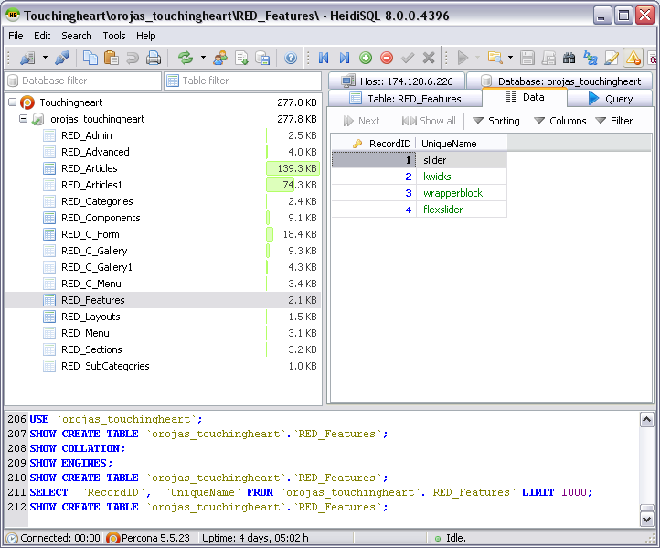
- Call class from /admin/mainnav.php. Line 90
